Exploratory Data Analysis (EDA) Report – Retail Sales Dataset
1. Introduction
This project focuses on conducting Exploratory Data Analysis (EDA) on a retail sales dataset containing 1,000 orders. The purpose of the analysis was to understand sales performance, customer purchasing behavior, product performance, payment preferences, order statuses, and sales trends over time.
The analysis was carried out using Microsoft Excel, Power Query, Power BI, and DAX. The cleaned data was transformed into an interactive Power BI dashboard to facilitate easier understanding and exploration of the findings.
2. Objectives
The main objectives of the analysis were to:
- Understand the overall characteristics of the retail sales data.
- Calculate basic descriptive statistics such as mean, median, and count.
- Identify trends in sales over time.
- Compare product performance.
- Examine customer payment methods and referral sources.
- Analyze the distribution of order statuses.
- Identify unusual patterns or possible outliers.
- Summarize the major findings from the dataset.
3. Data Preparation
Before carrying out the analysis, the dataset was reviewed and prepared for visualization.
The data preparation process included:
- Checking for missing values.
- Ensuring that columns had the correct data types.
- Validating quantity and total price values.
- Creating Month and Year fields for time-based analysis.
- Checking the consistency of the data.
- Preparing the cleaned dataset for analysis in Power BI.
3.2 DAX Calculations
After cleaning and transforming the data, DAX measures were created in Power BI to calculate the key descriptive statistics required for the analysis.
These included:
- Average Quantity per Order — to determine the average number of items purchased per order.
- Average Order Value — to determine the average amount spent per order.
- Average Unit Price — to understand the average price of products sold.
- Total Orders — to determine the total number of orders in the dataset.
- Median Order Value — to identify the middle order value and compare it with the average.
These calculations provided the numerical foundation for the KPI cards and helped support the analysis of the dataset.
This step was important because accurate analysis depends on having reliable and properly structured data.

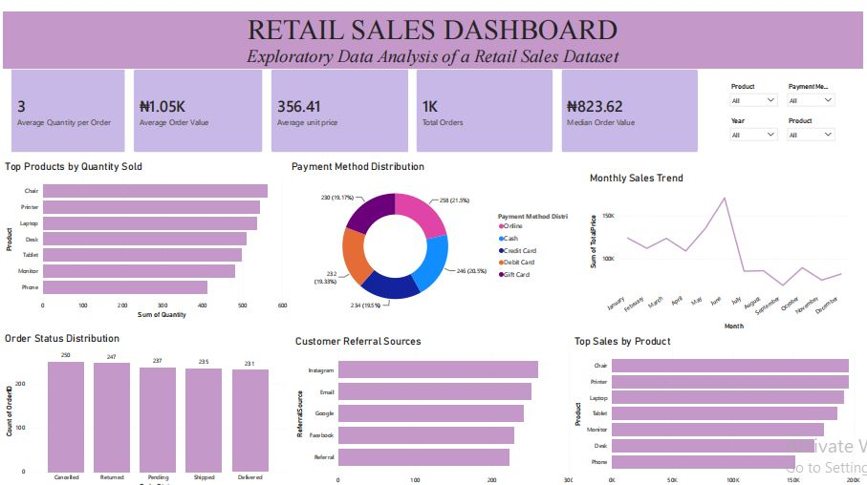

Figure 1: Retail Sales Power BI Dashboard
It shows the interactive Power BI dashboard developed for the retail sales analysis. It includes key performance indicators, product performance, payment method distribution, sales trends, order status distribution, customer referral sources, and interactive slicers.

4. Descriptive Statistics
Basic descriptive statistics were calculated to understand the general characteristics of the dataset.
Key Statistics
Metric | Result
Total Orders | 1,000
Average Quantity per Order | 3
Average Order Value | ₦1,050
Average Unit Price | ₦356.41
Median Order Value | ₦823.62
The dataset contains 1,000 orders, with customers purchasing an average of approximately 3 items per order.
The average order value is approximately ₦1,050, while the median order value is ₦823.62. The difference between the mean and median suggests that some orders have relatively higher values and may be influencing the overall average.
5. Analysis of Sales Trends
The sales trend was analyzed across the different months in the dataset.
The analysis shows that sales increased during the earlier months and reached their highest point around June. After this peak, sales experienced a noticeable decline in the following months.
This suggests that sales performance was not consistent throughout the year. The business may therefore need to investigate what contributed to the strong performance around June and consider promotional strategies during periods of lower sales.
6. Product Performance
Product performance was analyzed using both quantity sold and total sales.
Chair was identified as the top-performing product by quantity sold and also appeared among the strongest products in terms of sales value.
Other products, including printers, laptops, tablets, monitors, desks, and phones, also contributed significantly to overall sales.
This indicates that product demand varies across the product categories and that high-performing products should be monitored to ensure sufficient stock availability.
7. Payment Method Analysis
The dashboard was used to examine how customers paid for their purchases.
The analysis showed that payment methods were relatively well distributed across Online, Cash, Credit Card, Debit Card, and Gift Card.
No single payment method completely dominated the dataset. This suggests that customers use a variety of payment options, making it beneficial for the business to continue supporting multiple payment methods.
8. Order Status Analysis
Order statuses were also examined to understand the distribution of orders across different stages.
The dataset contains different order outcomes, including Cancelled, Returned, Pending, Shipped, and Delivered.
The distribution provides an overview of the customer order journey and can help the business monitor potential issues related to cancellations and returns.
Monitoring these categories can help identify areas where the business may improve order fulfillment and customer satisfaction.
9. Customer Referral Sources
Customer referral sources were analyzed to understand which channels were associated with the highest number of customers.
Instagram was the leading referral source in the dataset, followed by other sources such as Email, Google, Facebook, and Referral.
This suggests that Instagram may be an important channel for attracting customers and could be considered for further marketing investment.
10. Trends and Possible Outliers
One of the noticeable patterns in the analysis is the difference between the average order value of ₦1,050 and the median order value of ₦823.62.
Because the mean is higher than the median, the distribution appears to be influenced by some higher-value orders. These orders may represent potential high-value transactions or possible outliers that could be investigated further.
Another important trend is the significant increase in sales around June, followed by a decline in subsequent months.
These patterns are useful because they highlight areas that may require further investigation rather than simply reporting the overall sales figures.
11. Key Observations
The major findings from the analysis include:
- The dataset contains 1,000 retail orders.
- Customers purchase an average of 3 items per order.
- The average order value is approximately ₦1,050.
- The median order value is ₦823.62.
- Chair was the strongest product by quantity sold.
- Sales reached their highest point around June.
- Sales declined after the June peak.
- Payment methods were relatively balanced.
- Instagram was the leading customer referral source.
- The difference between the mean and median order values suggests the presence of higher-value transactions that may require further investigation.
12. Recommendations
Based on the findings, the following recommendations can be made:
- Increase inventory for high-demand products such as chairs.
- Investigate the factors responsible for the June sales peak.
- Consider targeted promotions during periods of declining sales.
- Continue supporting multiple payment methods.
- Invest further in effective referral channels, particularly Instagram.
- Monitor cancelled and returned orders to identify potential issues in the customer journey.
- Further investigate unusually high-value orders to understand customer purchasing behavior.
13. Conclusion
The Exploratory Data Analysis provided a clearer understanding of the retail sales dataset by examining descriptive statistics, product performance, customer behavior, payment methods, order statuses, referral sources, and sales trends.
The Power BI dashboard transformed the raw dataset into an interactive visual report, making it easier to identify patterns and communicate findings.
Overall, the analysis demonstrates how data can be used to identify business trends, highlight potential areas of concern, and support data-driven decision-making.

